Python Lab

Python Lab - Generate States and Union Territories

Create the directory, if not exists.

mkdir -p c:\python\indias\data

Download the code

<https://github.com/NATURE-LABS/India/blob/main/myindiagenStatesandUTdata.py>

Save in c:\python\indias

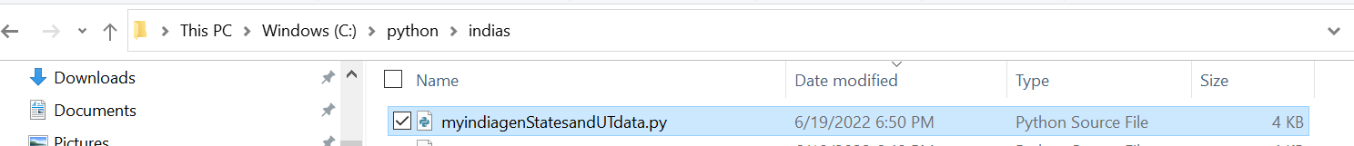

Execute the python

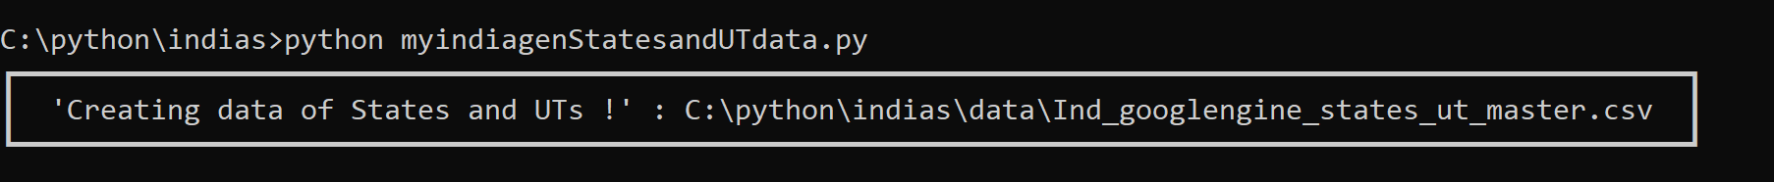

Ind_googlengine_states_ut_master.csv is generated in c:\python\indias\data

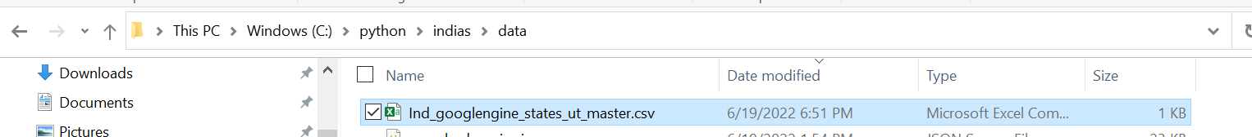

Open and view the India States and Union Territories and Capital(s)

|  |
| --- |
| States and Union Territories in India |
| Arunachal Pradesh,Itanagar |
| Assam,Dispur |
| Bihar,Patna |
| Chhattisgarh,Raipur |
| Goa,Panaji |
| Gujarat,Gandhinagar |
| Haryana,Chandigarh |
| Himachal Pradesh,Shimla |
| Jharkhand,Ranchi |
| Karnataka,Bangalore |
| Kerala,Thiruvananthapuram |
| Madhya Pradesh,Bhopal |
| Maharashtra,Mumbai |
| Manipur,Imphal |
| Meghalaya,Shillong |
| Mizoram,Aizawl |
| Nagaland,Kohima |
| Odisha,Bhubaneshwar |
| Punjab,Chandigarh |
| Rajasthan,Jaipur |
| Sikkim,Gangtok |
| Tamil Nadu,Chennai |
| Telangana,Hyderabad |
| Tripura,Agartala |
| Uttarakhand,Dehradun |
| Uttar Pradesh,Lucknow |
| West Bengal,Kolkata |
| Andaman and Nicobar Islands,Port Blair |
| Chandigarh,Chandigarh |
| Dadra and Nagar Haveli and Daman and Diu,Daman |
| Delhi,Delhi |
| Jammu and Kashmir,Jammu and Srinagar |
| Ladakh,Leh |
| Lakshadweep,Kavaratti |
| Puducherry,Puducherry |